DECT IP Телефон W76P

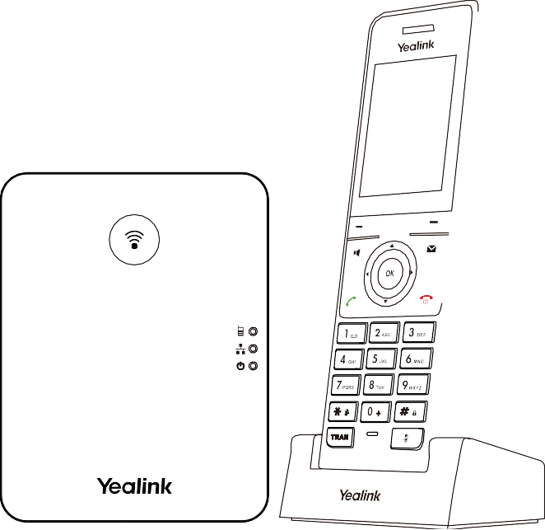

Краткое руководство (V1.0)

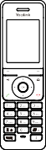
Комплектация

W56H
Трубка

Базовая станция 2 Блока питания

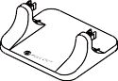
Подставка

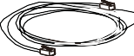
Ethernet кабель

Крышка Аккумулятор

Зажим для крепления на поясе
USB Подставка для зарядки
Краткое руководство

Примечание: Yealink W76P состоит из одной базовой станции W70B и одной трубки W56H.
Подготовка к эксплуатации
- Подключите питание базовой станции к сети используя метод a или b.
a. Блок питания b. PoE (Power over Ethernet)

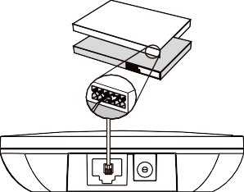
IEEE 802.3af Совместимый PoE хаб/коммутатор

Примечание:
- Если вы выбрали метод a, используйте блок питания Yealink (5В/0.6A). Сторонний блок питания может повредить станцию.
- Если вы выбрали метод b, вам не потребуется подключать блок питания. Убедитесь в совместимости PoE коммутатора.

2a. (Настольное использование) Использование подставки.
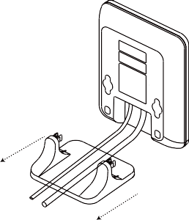
Закрепление устройства на подставке Удаление подставки

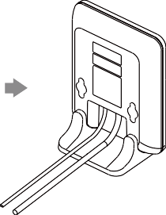
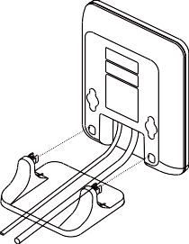
Совместите защелки с соответствующими отверстиями и протолкните вперед, вставив их в отверстия.

Вытащите защелки из отверстий по горизонтали.

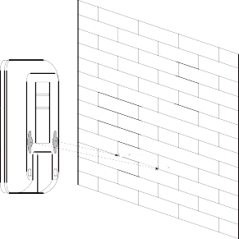
2b. (Настенное использование) Установка базовой станции на стену.
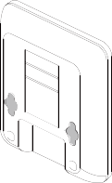
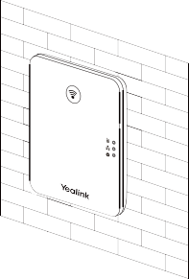
- Вставьте аккумулятор в трубку.
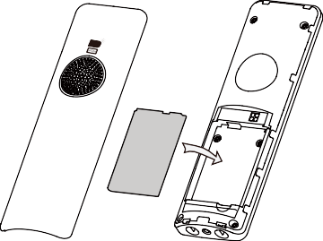
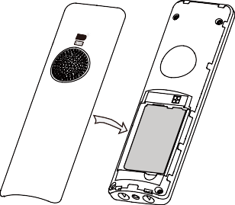

- Прикрепите крепление на пояс к трубке.
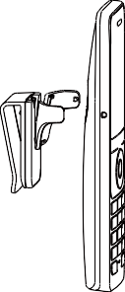
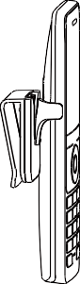
- (Опционально) Установите зарядный стакан на стенку.

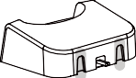
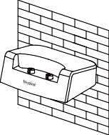
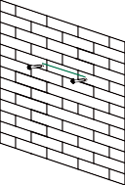
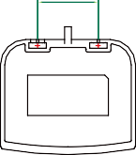36mm
- Вставьте трубку в зарядный стакан, чтобы зарядить.
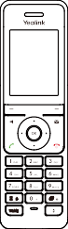
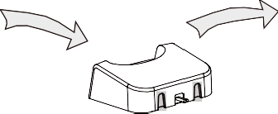
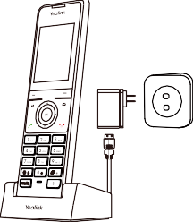
Примечание:
- Используйте блок питания Yealink (5В/0.6A). Блок питания стороннего производителя может повредить телефон.
- Проверьте состояние зарядки в правом верхнем углу ЖК-экрана.

Элементы управления

Динамик
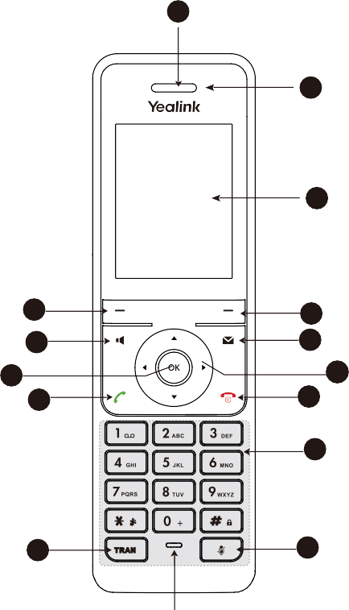1

  - LED Индикатор

  - Экран телефона

Программная клавиша 4
Клавиша спикерфона 6

  - Программная клавиша
  - Клавиша сообщений

Клавиша OK 8 7 Навигационная клавиша

Клавиша 10
9 Клавиша сброса вызова/

принятия вызова /питания
11 Клавиатура

Клавиша 12 13 Клавиша выключения микрофона
трансфера

14

Микрофон

Regulatory Notices

Operating Ambient Temperatures
- Operating temperature: +14 to 122°F (-10 to 50°C)
- Relative humidity: 5% to 90%, noncondensing
- Storage temperature: -22 to +158°F (-30 to +70°C)

Warranty
Our product warranty is limited only to the unit itself, when used normally in accordance with the operating instructions and the system environment. We are not liable for damage or loss resulting from the use of this product, or for any claim from a third party. We are not liable for problems with Yealink device arising from the use of this product; we are not liable for financial damages, lost profits, claims from third parties, etc., arising from the use of this product.

Explanation of the symbols

DC symbol
is the DC voltage symbol.

WEEE Warning symbol
To avoid the potential effects on the environment and human health as a result of the presence of hazardous substances in electrical and electronic equipment, end users of electrical and electronic equipment should understand the meaning of the crossed-out wheeled bin symbol. Do not dispose of
WEEE as unsorted municipal waste and have to collect such WEEE separately.

Restriction of Hazardous Substances Directive (RoHS)

Battery Requirements
- Do not immerse the battery into water, which could short-circuit and damage the battery.
- Do not expose the battery to an open flame or leave the battery where it could be subjected to extremely
high temperatures, which could cause the battery to explode.
- Do power the handset off before removing the battery.
- Do not try to use the battery for the power supply of any device other than this handset.
- Do not open or mutilate the battery, released electrolyte is corrosive and may cause damage to your eyes or skin.
- Use only the rechargeable battery pack delivered with the handset or those rechargeable battery packs expressly recommended by Yealink.
- Defective or exhausted battery should never be disposed of as municipal waste. Return old battery to the battery supplier, a licensed battery dealer or a designated collection facility.

Cleaning Requirements
- Before cleaning the device, disconnect it from the power supply.
- Use a piece of soft, dry and anti-static cloth to clean the device.
- Keep the power plug clean and dry.

Troubleshooting
The unit cannot supply power to Yealink device. There is a bad connection with the plug.
- Clean the plug with a dry cloth.
- Connect it to another wall outlet.
The usage environment is out of operating temperature range.

This device complies with the requirements of the EU RoHS Directive. Statements of compliance can be 1. Use in the operating temperature range.

obtained by contacting support@yealink.com.

Safety Instructions

Save these instructions. Read these safety instructions before use!

General Requirements
The cable between the unit and the Yealink device is connected incorrectly.
  - Connect the cable correctly.
You cannot connect the cable properly.
- You may have connected a wrong Yealink device.
- Use the correct power supply. Some dust, etc., may be in the port.

  - Before you install and use the device, read the safety instructions carefully and observe the situation 1. Clean the port.

during operation.
Contact your dealer or authorized service facility for any further questions.

  - During the process of storage, transportation, and operation, please always keep the device dry and FCC Statement
clean, avoid collision and crash. This device complies with part 15 of the FCC Rules. Operation is subject to the following two conditions: (1) this
  - Please attempt not to dismantle the device by yourself. In case of any discrepancy, please contact the device may not cause harmful interference, and (2) this device must accept any interference received, including
appointed maintenance center for repair. interference that may cause undesired operation.
  - Please refer to the relevant laws and statutes while using the device. Legal rights of others should be Any Changes or modifications not expressly approved by the party responsible for compliance could void the

respected as well.

Environmental Requirements
  - Place the device at a well-ventilated place. Do not expose the device under direct sunlight.
  - Keep the device dry and free of dusts.
user’s authority to operate the equipment.

IC Statement
This device complies with Industry Canada’s licence-exempt RSSs. Operation is subject to the following two
conditions:

  - Do not place the device on or near any inflammable or fire-vulnerable object, such as rubber-made (1) this device may not cause interference; and

materials.
Keep the device away from any heat source or bare fire, such as a candle or an electric heater.
•

Operating Requirements
  - Do not let a child operate the device without guidance.
  - Do not let a child play with the device or any accessory in case of accidental swallowing.
  - Please use the accessories provided or authorized by the manufacturer only.
(2) this device must accept any interference, including interference that may cause undesired operation of the device. CAN ICES-3(B)
Le présent appareil est conforme aux CNR d’Industrie Canada applicables aux appareils radio exempts de licence. L’exploitation est autorisée aux deux conditions suivantes :
- l’appareil ne doit pas produire de brouillage;
- l’utilisateur de l’appareil doit accepter tout brouillage radioélectrique subi, même si le brouillage est susceptible d’en compromettre le fonctionnement.NMB-3(B)

  - The power supply of the device shall meet the requirements of the input voltage of the device. Please use
Radiation Exposure Statement
the provided surge protection power socket only.
  - Before plugging or unplugging any cable, make sure that your hands are completely dry. This equipment complies with FCC and IC radiation exposure limits set forth for an uncontrolled environment.
  - Do not spill liquid of any kind on the product or use the equipment near water, for example, near a This equipment should be installed and operated with minimum distance 20cm between the radiator and your
bathtub, washbowl, kitchen sink, wet basement or near a swimming pool. body.
  - During a thunderstorm, stop using the device and disconnect it from the power supply. Unplug the power Cet émetteur ne doit pas être Co-placé ou ne fonctionnant en même temps qu’aucune autre antenne ou plug and the Asymmetric Digital Subscriber Line (ADSL) twisted pair (the radio frequency cable) to avoid émetteur. Cet équipement devrait être installé et actionné avec une distance minimum de 20 centimètres entre
lightning strike. le radiateur et votre corps.
  - If the device is left unused for a rather long time, disconnect it from the power supply and unplug the Contact Information

power plug.

YEALINK NETWORK TECHNOLOGY CO.,LTD.

  - When there is smoke emitted from the device, or some abnormal noise or smell, disconnect the device from 309, 3rd Floor, No.16, Yun Ding North Road, Huli District, Xiamen City, Fujian, P.R.C
the power supply, and unplug the power plug immediately.

  - Contact the specified maintenance center for repair.
  - Do not insert any object into equipment slots that is not part of the product or auxiliary product.

YEALINK (EUROPE) NETWORK TECHNOLOGY B.V.
Strawinskylaan 3127, Atrium Building, 8th floor, 1077ZX Amsterdam, The Netherlands

  - Before connecting a cable, connect the grounding cable of the device first. Do not disconnect the grounding cable until YEALINK (USA) NETWORK TECHNOLOGY CO., LTD.

you disconnect all other cables.
999 Peachtree Street Suite 2300, Fulton, Atlanta, GA, 30309, USA

Made in China

About Yealink
Yealink (Stock Code: 300628) is a global brand that specializes in video conferencing, voice communications and collaboration solutions with best-in-class quality, innovative technology and user-friendly experience. As one of the best providers in more than 140 countries and regions, Yealink ranks No.1 in the global market share of SIP phone shipments (Global IP Desktop Phone Growth Excellence Leadership Award Report, Frost & Sullivan, 2019).

Technical Support
Visit Yealink WIKI (http://support.yealink.com/) for firmware downloads, product documents, FAQ, and more. For better service, we sincerely
recommend you to use Yealink Ticketing system (https://ticket.yealink.com) to submit all your technical issues.

Need more help?

Yealink Documentation& Video

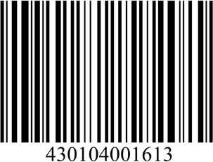
YEALINK(XIAMEN) NETWORK TECHNOLOGY CO.,LTD.
Web: www.yealink.com
Copyright©2021 YEALINK(XIAMEN) NETWORK
TECHNOLOGY CO.,LTD.All rights reserved.

